AWS Detective
Imagine if someone entered your house without permission, or if something suspicious happened — like a window broken or a door left open.
You would want to investigate what happened — who, when, how, and why.
In the cloud (AWS), if something suspicious happens (like someone trying to hack your servers or strange activity by a user), you also need to investigate.
AWS Detective is a service that helps you find out what happened by collecting data, connecting the dots, and making it easy to understand.
In short:
AWS Detective helps you investigate security issues in your AWS account, just like a detective solves a case in real life!
AWS Detective is a cloud-native security investigation service that helps you analyze, investigate, and quickly identify the root cause of potential security issues or suspicious activities across your AWS resources.
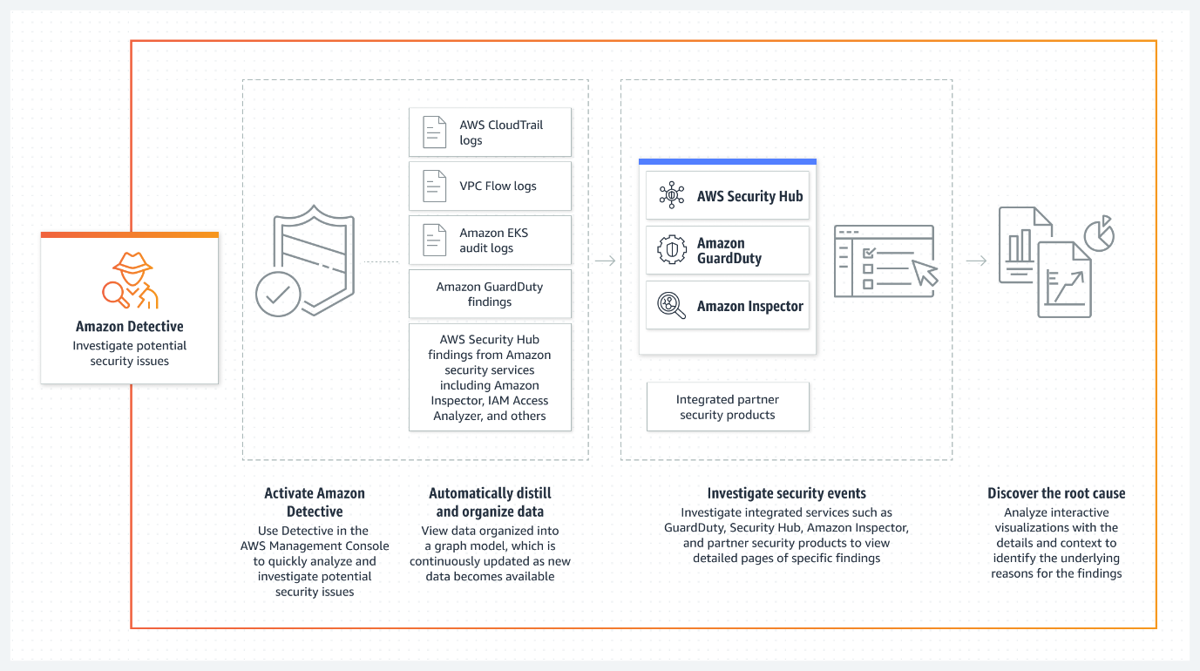
Instead of manually correlating logs and digging through data from multiple sources, Detective automatically aggregates and visualizes data to help security analysts understand what happened, when, and how.
What AWS Detective Does:
1. Automatically collects and organizes data:
- Pulls data from:
  - Amazon GuardDuty (findings),
  - AWS CloudTrail (API activity),
  - Amazon VPC Flow Logs (network activity).
2. Creates visualizations and timelines:
- Helps trace the steps of an attacker or insider threat.
- Graphs show relationships between users, resources, IP addresses, and findings.
3. Enables deep, fast security investigations:
- Helps answer: Who accessed what? From where? Was it abnormal?
- Designed to reduce mean time to respond (MTTR) in incident response.
Example Use Case:
Scenario:
A GuardDuty alert notifies you that an EC2 instance is making calls to a known malicious domain.
With AWS Detective, you can:
- Click the GuardDuty finding → "Investigate in Detective".
- View associated:
  - IAM role or user.
  - API calls made by the role (from CloudTrail).
  - Network flows (IP addresses and ports).
  - Other related findings.
- Analyze if:
  - The IAM role was compromised.
  - Lateral movement occurred.
  - Other accounts or instances are affected.
When to Use AWS Detective:
Use Case | Why Use Detective?
After a GuardDuty alert | Drill into associated activity (CloudTrail, network flows).
Suspicious user activity | Investigate abnormal API behavior (e.g., privilege escalation).
EC2 instance behaving abnormally | Trace connections, data movement, and roles involved.
Investigating insider threats | Analyze behavior and access patterns over time.

How Detective Helps in Security:
- Reduces investigation time by providing structured data and context.
- Improves visibility across services without needing custom dashboards.
- Aids compliance and forensics by showing detailed audit trails and graphs.

Lab: Investigating Security Findings with AWS Detective

Lab Objectives
By the end of this lab, students will:
- Enable AWS Detective.
- Generate a GuardDuty finding (simulated threat).
- Use AWS Detective to analyze and investigate the finding.
- Learn to navigate the Behavior Graph, entity profiles, and event timelines.
- Understand relationships between IAM users, resources, and network activity.
Lab Prerequisites
- AWS Account with Admin or SecurityAudit permissions.
- Region where GuardDuty and Detective are available.
- GuardDuty already enabled (or you will enable it as part of this lab).
Step-by-Step Instructions

Step 1: Enable GuardDuty
- Go to the AWS Console → search for GuardDuty.
- Click “Enable GuardDuty” (if not already enabled).
- Let it run in the background — no configuration required.

Step 2: Enable AWS Detective
- In the AWS Console, search and open AWS Detective.
- Click “Enable Detective”.
- Select the AWS account and region.
- Click “Enable” — it may take a few minutes to initialize the Behavior Graph.

Step 3: Simulate a Security Finding (Optional but Recommended)
To generate a finding for investigation, you can:
Option 1: Use AWS GuardDuty Tester Script
curl https://guardduty.amazonaws.com/usage/simulator/ec2-internal-ip-port-probe
This triggers a simulated port probe finding.
Option 2: Trigger a real but safe CloudTrail event
Try logging in using an IAM user with incorrect credentials or access a denied resource.

Step 4: Investigate Findings in GuardDuty
- Go to GuardDuty → Findings.
- Select a finding (preferably from the simulator).
- Click on "Investigate in Detective" — it redirects you to AWS Detective.

Step 5: Analyze with AWS Detective
In Detective:
- On the left sidebar, choose Findings → All findings.
- Select the finding.
- Review the details, such as:
  - Finding type, severity, time, and source.
  - Entities involved (EC2 instance, IAM role, IP address).
- Click on an entity (e.g., EC2 instance or IAM user).
- View:
  - Profile page of the resource.
  - Event timeline (API calls from CloudTrail).
  - Associated findings, network flows, and access activity.
- Use the Behavior Graph to explore relationships and dependencies.

Step 6: Explore Timeline View
- Click on any entity → "View in time window".
- Select a 24-hour window before/after the finding.
- Analyze:
  - What API calls were made?
  - From which IP addresses?
  - Which resources were accessed?

Step 7: Clean Up
- Optional: You may disable Detective after the lab.
- Delete test S3 buckets or IAM users if created.

